Cryptography Final Exam 2009/06/16

Part I (3 points each)

- Apply Fermat’s primality test on 33. Which is NOT a witness of compositeness?
A. 7 B. 10 C. 13 D. 16 E. None of the above

- Which is the key length (in bits) of two-key Triple-DES?
A. 112 B. 128 C. 160 D. 192 E. None of the above

- The S-box of AES is constructed by combining the function f (x) = x ª defined on GF₂₅₆ with an invertible affine transformation. Which is the value of a?
A. 254 B. 255 C. 256 D. 257 E. None of the above

- Which stream cipher is NOT in the portfolio of the eSTREAM project?
- Rabbit B. Trivium C. Salsa20 D. RC4 E. None of the above

- Which mode of operation has no error propagation? That is, a transmission error of one bit causes a decryption error of only one bit.
A. ECB B. CBC C. OFB D. CFB E. None of the above

6. Suite B is a set of algorithms promulgated by National Security Agency (NSA) as part of Cryptographic Modernization Program. Which is NOT included in Suite B?
A. ECDH B. ECDSA C. AES-256 D.SHA-256 E. None of the above

7. Let m_{i}’s and c_{i}’s be plaintext and ciphertext blocks respectively. With a decryption algorithm d and a key k, which is the decryption operation of CBC mode for i > 1?
A. m_{i} = d_{k} (c_{i} ⊕ m_{i−1}) B. m_{i} = d_{k} (c_{i}) ⊕ m_{i−1}
C. m_{i} = d_{k} (c_{i} ⊕ c_{i−1}) D. m_{i} = d_{k} (c_{i}) ⊕ c_{i−1} E. None of the above

8. Which signature scheme based on discrete logarithm problem has the message recovery property? A. ElGamal signature B. DSA
C. Nyberg-Rueppel signature D. Schnorr signature E. None of the above

9. Which is NOT one of the operations of IDEA encryption?
- Multiplication modulo 2¹⁶+1 B. Addition modulo 2¹⁶
- Exponentiation modulo 2¹⁶−1 D. Exclusive OR E. None of the above

10. Which statement is FALSE about PKI?
A. CRL is a list of the serial numbers of all the revoked certificates
B. CA establishes the identity of users, but does not sign certificates
C. SSL aims to provide channel security to fulfill commercial requirement
D. X509 defines a structure for public key certificates
E. None of the above

Part II (3 points each)

- To factor 9487 by the quadratic sieve, we define f (x) = x² – 9487.
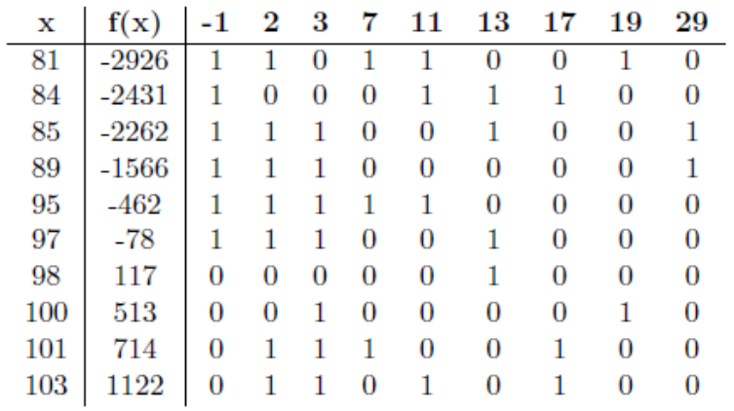Note that 513 = 3³ × 19.
- From the table, ( 81 × 11 × 12 )² ≡ a² (mod 9487) where a is an integer.
- The factorization is 9487 = 13 × 14 .

- DES and Triple-DES support the data block size of 15 bits. AES supports the data block size of 16 bits.

- A cryptographic hash function h should satisfy the following properties.
- Pre-image Resistance: Given y, hard to find x such that 17 .
- Collision Resistance: Hard to find any x ≠ x′ such that 18 .

- Consider the sequences generated by an LFSR with register length 6.
- The largest possible period of a sequence is 19 .
- With the connection polynomial x⁶ + x³ + 1, the period of a non-zero sequence is 20 .

- Using Diffie-Hellman key exchange scheme on Z₃₇ with the generator g = 2, Alice chooses 12 and Bob chooses 5 in private.
- The element in Z₃₇ that Alice sends to Bob is 21 .
- The agreed key is 22 .

- The following reference code comes from the book “The Design of Rijndael” written by J. Daemen and V. Rijmen:

typedef unsigned char word8;

word8 Logtable[256] = {
0, 0, 25, 1, 50, 2, 26,198, 75,199, 27,104, 51,238,223, 3,100, 4,224, 14,
52,141,129,239, 76,113, 8,200,248,105, 28,193,125,194, 29,181,249,185, 39,106,
77,228,166,114,154,201, 9,120,101, 47,138, 5, 33, 15,225, 36, 18,240,130, 69,
53,147,218,142,150,143,219,189, 54,208,206,148, 19, 92,210,241, 64, 70,131, 56,
102,221,253, 48,191, 6,139, 98,179, 37,226,152, 34,136,145, 16,126,110, 72,195,
163,182, 30, 66, 58,107, 40, 84,250,133, 61,186, 43,121, 10, 21,155,159, 94,202,
78,212,172,229,243,115,167, 87,175, 88,168, 80,244,234,214,116, 79,174,233,213,
231,230,173,232, 44,215,117,122,235, 22, 11,245, 89,203, 95,176,156,169, 81,160,
127, 12,246,111, 23,196, 73,236,216, 67, 31, 45,164,118,123,183,204,187, 62, 90,
251, 96,177,134, 59, 82,161,108,170, 85, 41,157,151,178,135,144, 97,190,220,252,
188,149,207,205, 55, 63, 91,209, 83, 57,132, 60, 65,162,109, 71, 20, 42,158, 93,
86,242,211,171, 68, 17,146,217, 35, 32, 46,137,180,124,184, 38,119,153,227,165,
103, 74,237,222,197, 49,254, 24, 13, 99,140,128,192,247,112, 7};

word8 Alogtable[256] = {
1, 3, 5, 15, 17, 51, 85,255, 26, 46,114,150,161,248, 19, 53, 95,225, 56, 72,
216,115,149,164,247, 2, 6, 10, 30, 34,102,170,229, 52, 92,228, 55, 89,235, 38,
106,190,217,112,144,171,230, 49, 83,245, 4, 12, 20, 60, 68,204, 79,209,104,184,
211,110,178,205, 76,212,103,169,224, 59, 77,215, 98,166,241, 8, 24, 40,120,136,
131,158,185,208,107,189,220,127,129,152,179,206, 73,219,118,154,181,196, 87,249,
16, 48, 80,240, 11, 29, 39,105,187,214, 97,163,254, 25, 43,125,135,146,173,236,
47,113,147,174,233, 32, 96,160,251, 22, 58, 78,210,109,183,194, 93,231, 50, 86,
250, 21, 63, 65,195, 94,226, 61, 71,201, 64,192, 91,237, 44,116,156,191,218,117,
159,186,213,100,172,239, 42,126,130,157,188,223,122,142,137,128,155,182,193, 88,
232, 35,101,175,234, 37,111,177,200, 67,197, 84,252, 31, 33, 99,165,244, 7, 9,
27, 45,119,153,176,203, 70,202, 69,207, 74,222,121,139,134,145,168,227, 62, 66,
198, 81,243, 14, 18, 54, 90,238, 41,123,141,140,143,138,133,148,167,242, 13, 23,
57, 75,221,124,132,151,162,253, 28, 36,108,180,199, 82,246, 1};

/* The tables Logtable and Alogtable are used to perform multiplications in GF(256)

word8 mul(word8 a, word8 b) {
if (a && b) return Alogtable[(Logtable[a] + Logtable[b])%255];
else return 0;
}

GF₂₅₆ is generated by m(x) = x⁸ + x⁴ + x³ + x + 1 in AES. The above tables (20 entries in each row) are built by the primitive element x + 1 of GF ₂ [ x] / < m(x) > ≅ GF₂₅₆.
- (x + 1)^{n} mod m(x) = x⁴ + x, then n = 23 .
- (x + 1)¹⁷⁹ mod m(x) = 24 (a polynomial in GF₂ [x] of degree < 8)
- (x⁵ + x²)⁻¹ mod m(x) = 25 (a polynomial in GF₂ [x] of degree < 8)
- Finish the subroutine computing patched multiplicative inverses in GF₂₅₆:
word8 inverse(word8 a) {
if (a) return Alogtable[ 26 ];
else return 0;
}

- Consider Shamir’s Secret Sharing with threshold 3 over GF₁₇. The secret a₀ is hided as the constant of the polynomial f (x) = a₂ x² + a₁ x + a₀ ∈ GF₁₇[x].
- The points (1, 6), (2, 10), (4, 2) that f (x) passes are obtained from three participants. Then the secret is recovered as a₀ = 27 .
- The point (3, y) is also distributed to another participant, then y = 28 .

- Complete the Miller-Rabin test to determine the primality of an integer n:
Write n –1 = 2^{k} m where m is odd
Choose a ∈ {1, …, n –1}
Compute b = 29 (mod n)
If (b ≠ 1 and b ≠ (n − 1))
i = 1
While (i < k and b ≠ (n − 1))
b = 30 (mod n)
If (b = 1) Output (Composite, a)
i = i + 1
If (b ≠ (n − 1)) Output (Composite, a)
Output “Probable Prime”

Part III (Write down all details of your work)

31 (4 points)
Both 1009 and 10091 are prime numbers. Find an element of the multiplicative group Z₁₀₀₉₁* whose order is 1009. Explain why your choice is correct. (Hint: The domain parameter selections of DLP-based cryptosystems such as DSA and ElGamal have similar process.)

32 (6 points)
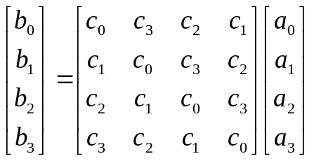 In the MixColumns operation of AES, each column is treated as a polynomial over GF₂₅₆ and is then multiplied modulo x⁴ + 1 with a fixed polynomial c(x) = c₃ x³ + c₂ x² + c₁ x + c₀. In AES, c(x) = ‘03’x³ + ‘01’x² + ‘01’x + ‘02’ is selected specifically. This step can also be viewed as a multiplication by a particular matrix, b = C a over GF₂₅₆:

- A polynomial c(x) is called self-invertible if c(x)² ≡ 1 (mod x⁴ + 1). Show that c(x) is self-invertible if and only if c(x) is of the form u x³ + v x² + u x + (v +1), where u and v are arbitrary elements in GF₂₅₆.
- The diffusion effect of the operation is evaluated by the branch number:
min _{a ≠ 0} (W(a) + W(Ca))
where a is a 4-byte vector, C is the matrix multiplier, W is the weight of a vector (the number of non-zero entries). Show that the maximal branch number is 5.
Remark: c(x) = ‘03’x³ + ‘01’x² + ‘01’x + ‘02’ in AES has branch number 5.
- Show that the branch number of every self-invertible polynomial is less than or equal to 4.
Cryptography Final Exam 2009/06/16
Name: ____________ Student ID number: ____________

1 | 2 | 3 | 4 | 5 | 6 | 7 | 8 | 9 | 10
11 |  | 12 |  | 13 |  | 14 |  | 15
16 |  | 17 |  | 18 |  | 19 |  | 20
21 |  | 22 |  | 23 |  | 24 |  | 25
26 |  | 27 |  | 28 |  | 29 |  | 30

31 32
Cryptography Final Exam 2009/06/16
Solution
1 | 2 | 3 | 4 | 5 | 6 | 7 | 8 | 9 | 10
B | A | A | D | C | E | D | C | C | B
11 |  | 12 |  | 13 |  | 14 |  | 15
95 |  | 100 |  | 53 |  | 179 |  | 64
16 |  | 17 |  | 18 |  | 19 |  | 20
128 |  | y = h(x) |  | h(x) = h(x') |  | 63 |  | 9
21 |  | 22 |  | 23 |  | 24 |  | 25
26 |  | 10 |  | 224 |  | x⁶ + x⁴ + x³ |  | x⁶+ x⁴+ x²+ 1
26 |  | 27 |  | 28 |  | 29 |  | 30
255 − Logtable[a] |  | 8 |  | 3 |  | a^{m} |  | b²

31 g = 2^{(10091−1)/1009} = 2¹⁰ = 1024,
g¹⁰⁰⁹ = 1 (mod 10091) by the Little Fermat Theorem

32 (c) min _{a ≠ 0} (W(a) + W(Ca)) ≤ 2 + 2 = 4, since
